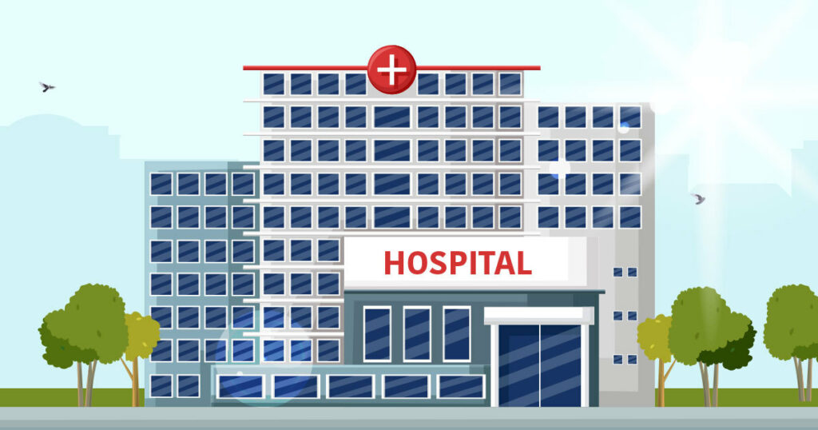

**AIR-FORCE HOSPITAL PROJECT**

Farah Khaled 2020/02731

Youssef Mohamed Sayed 2020/04075

**Introduction:**

Our project aims to support the hospital’s employees (doctors-receptionists) and patients. In this program, each of the following people can do something based on his privilege:

1. Doctors can update the patient's status by entering their IDs.
2. Receptionists can check available rooms and remove or add reservations.
3. Patients can display all their data and remove their reservations.

**A Flow Chart that represents the Program:**

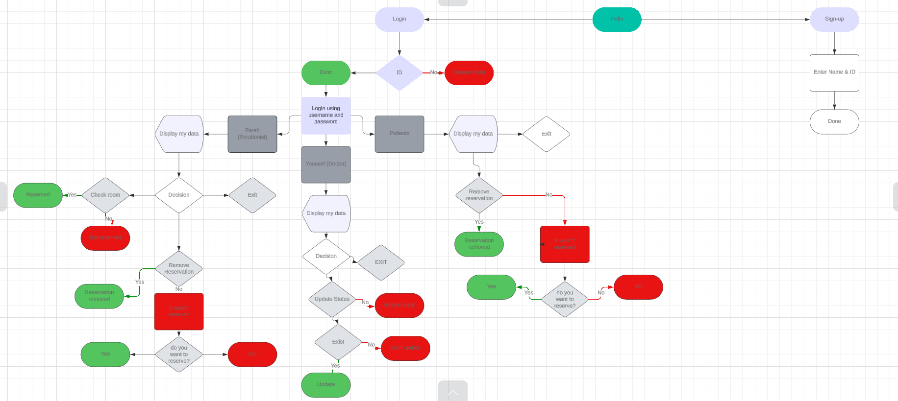

**Key data to test the program:**

1. **Receptionist**:

Id: 1234

Username: Farah

Password:1234

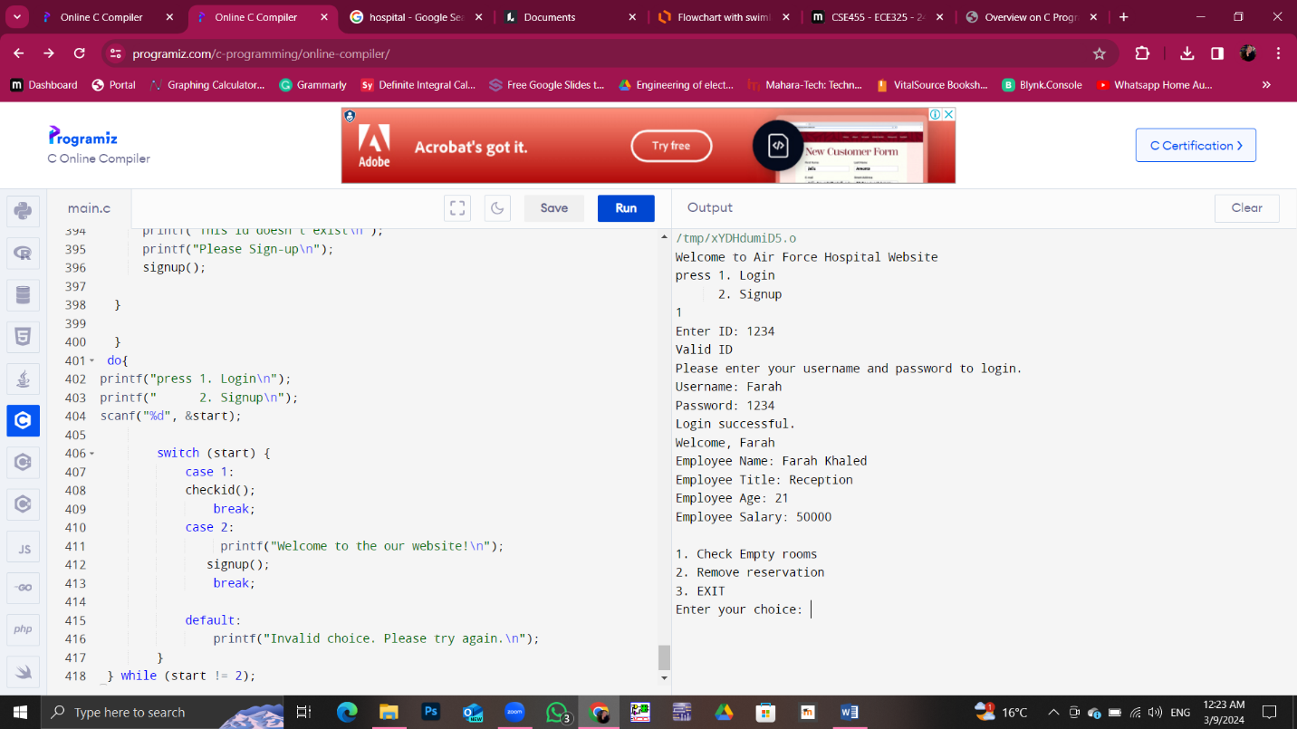

In this screenshot, we are just testing the program by entering the id, logging in using username and password, and then watching the home screen of the receptionist account.

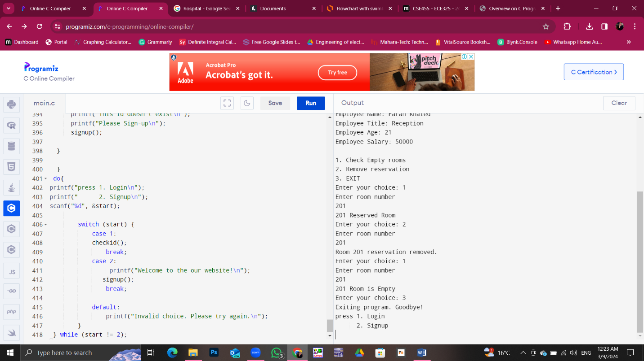

Testing the check empty rooms function for room 201 and it was reserved

Then, testing the remove reservation function that removed the reservation, tested for the last time that it was removed.

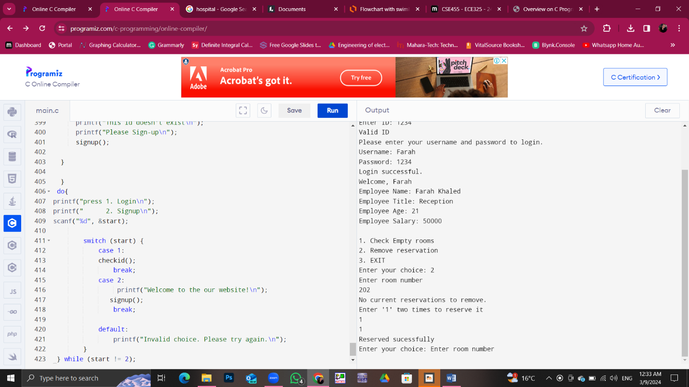

Testing the twist that we added to the remove reservation function that if there was no reservation as it was at room 202 it asks the user if he needs to reserve it or not and does this for him.

1. **Doctor**:

Id:1235

Username: Youssef

Password:1235

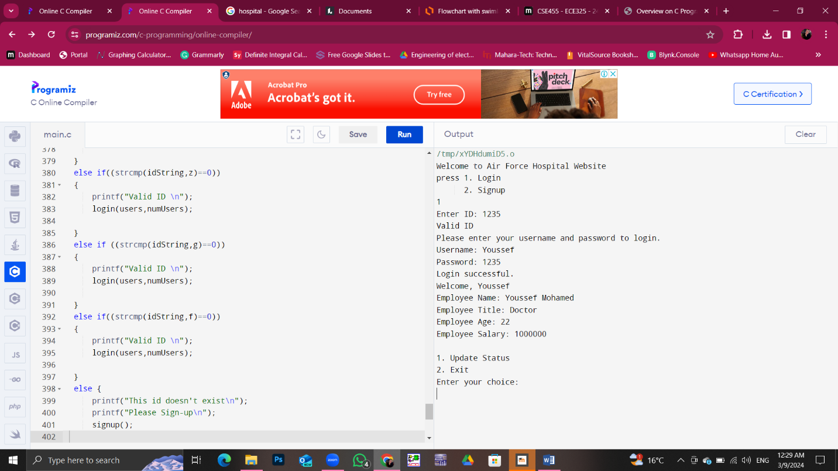

For the doctor authorities and privileges, he doesn’t need anything from the system except to check his own data ex: salary and just update the patient’s status

In this screenshot, we can just see his home screen.

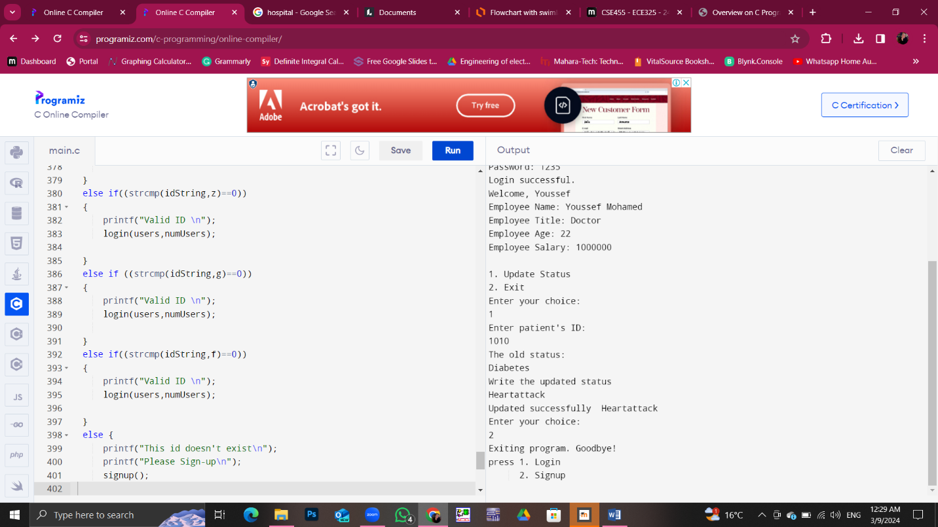

Here is testing his only function update the patient data that was having diabetes and we changed it to heart attack and printed it before and after to check if the system really changed it or not.

1. Patient’s data:

Id: 1010

Username: patient1

Password: 1010

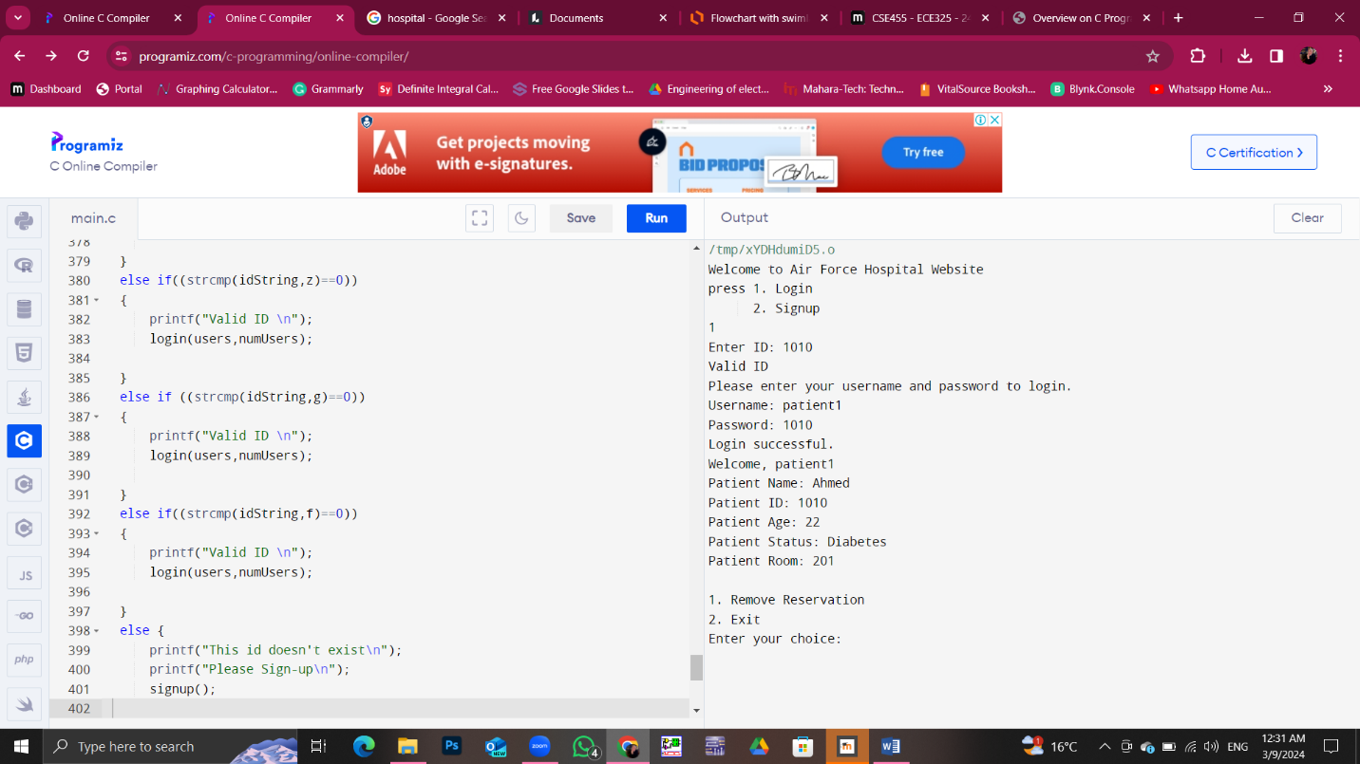

Here’s the patient’s home screen showing his own data and the remove reservation function he has that we have already tested it before.

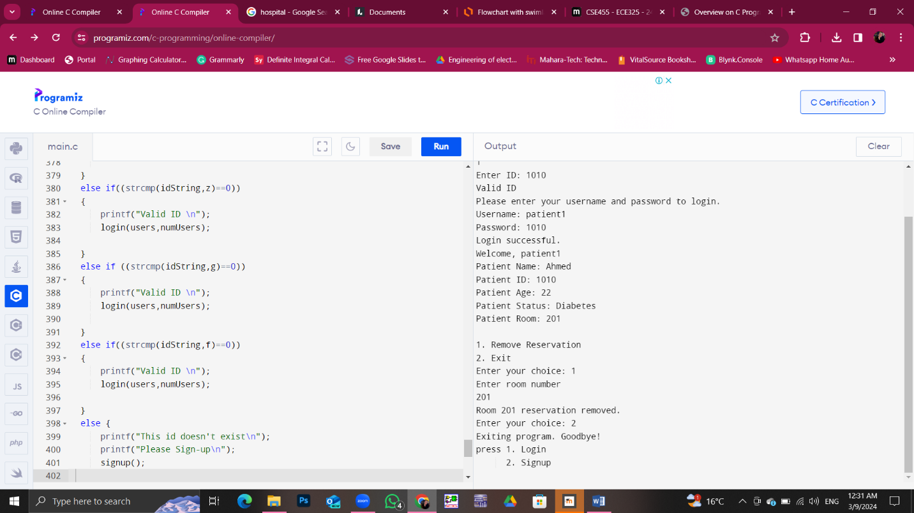

For this screenshot we are again testing the remove reservation that can remove reservation of the reserved room and asks the user if the room isn’t reserved if he wants to reserve it or not.

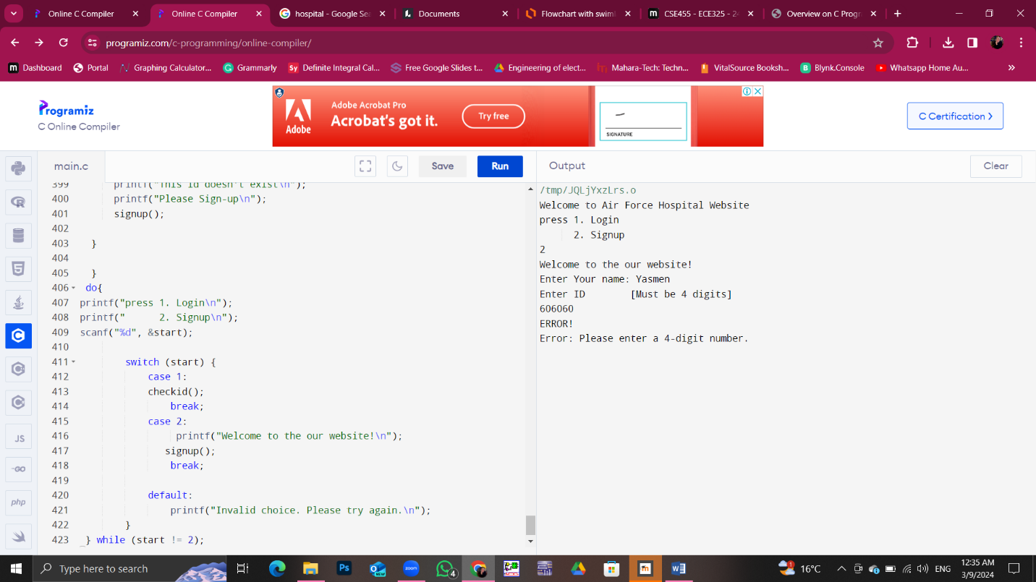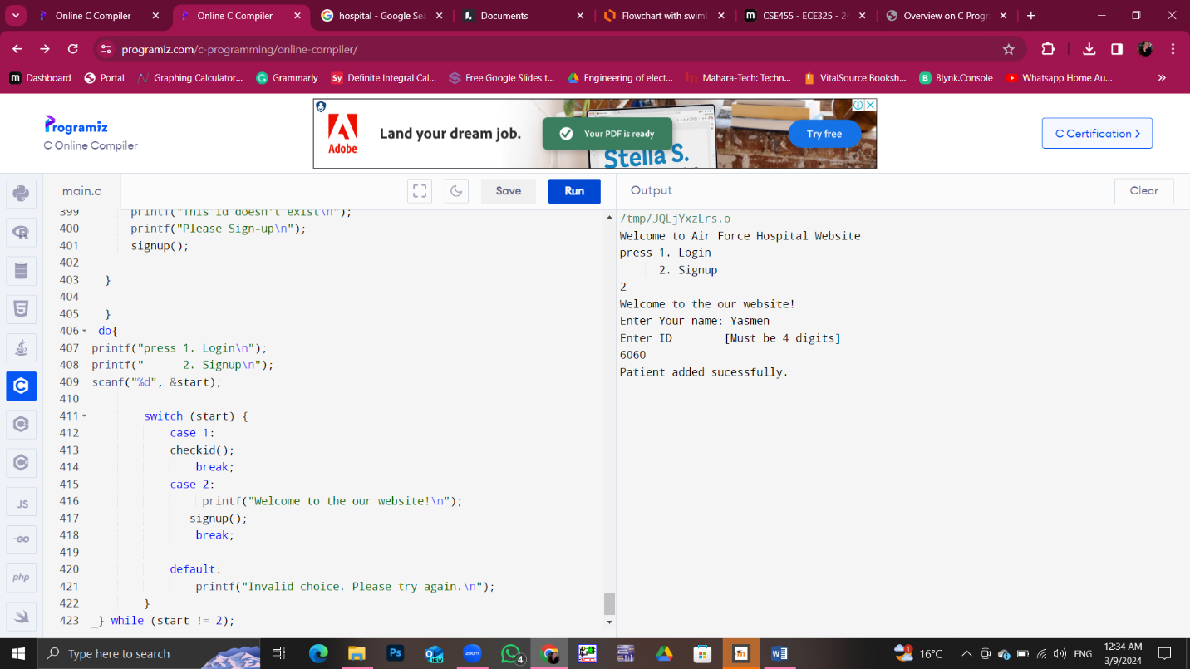4.Sign-up:

Both screenshots are testing the signup program with its error.

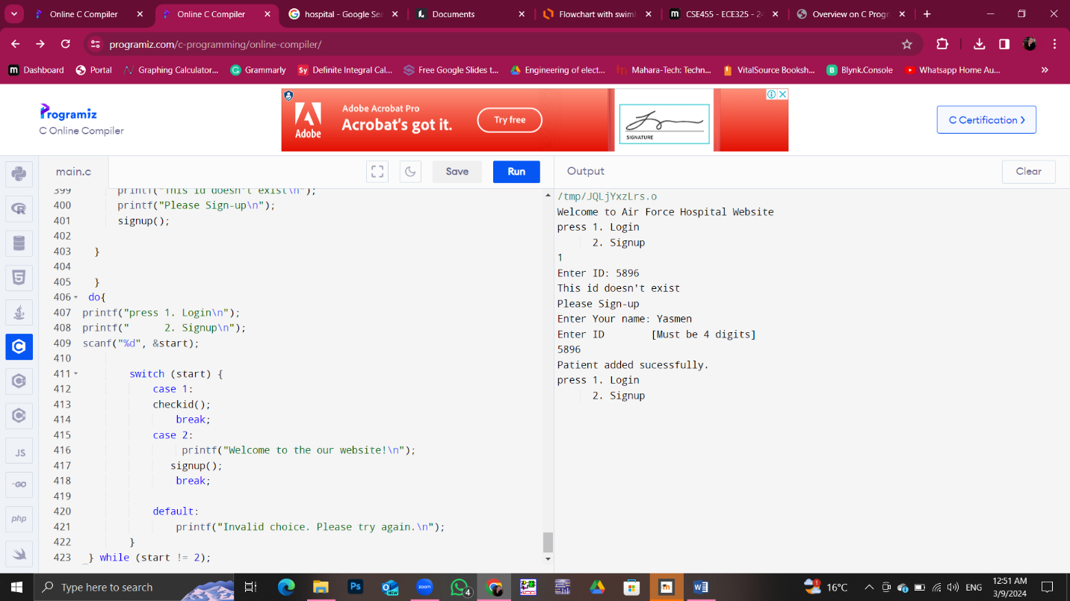

In the last screenshot we’re testing if the user logged in but entered an ID that doesn’t exist the system will ask him to sign-up.

**Errors and problems that faced us:**

1. Online Compiler:

As it is clear from our screenshots we’re using the online compiler because both of us tried Code Blocks and Visual Studio and it didn’t work.so, this caused some errors and problems while coding.

1. some functions are made in the main and then called also in the main we know that it was better to be outside the main but this was one of the online compiler’s errors that didn’t work except like this.
2. When the patient enters any room he could remove its reservation this is not efficient enough.
3. 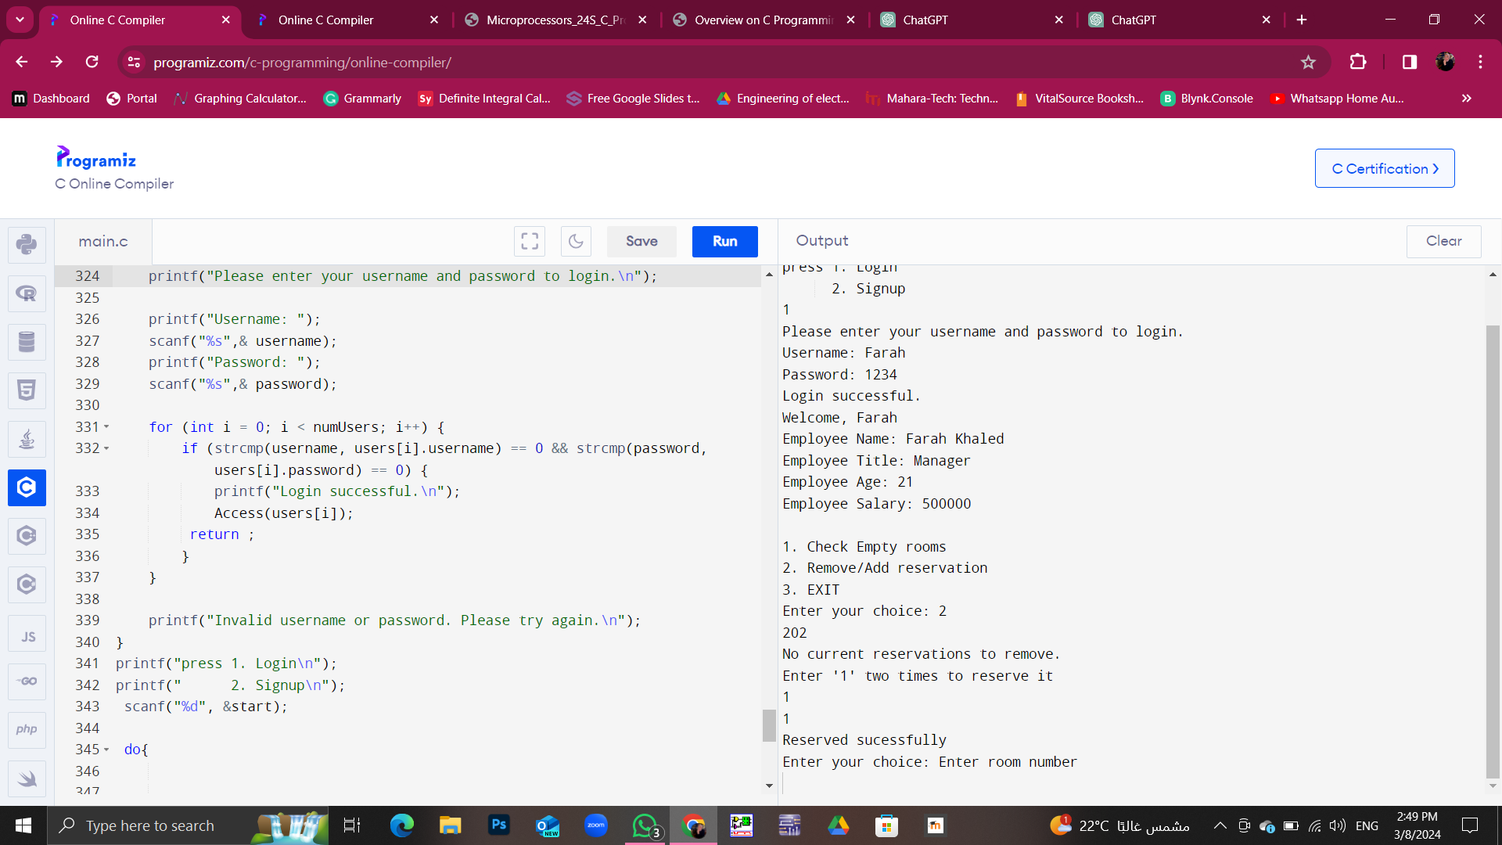The word “Enter room number” isn’t meant to be here but we didn’t find a solution to it.